DOCKER NETWORKING

WHAT IS DOCKER NETWORK
Docker networking is a way to connect containers to each other and to the host system so they can communicate easily.

TYPES OF DOCKER NETWORKS
BRIDGE
- Bridge Network is Docker’s default private network.
- It allows containers to communicate with each other internally on the same host.
- Containers can also access the internet through the host machine.
- External users can access containers using port mapping
- Example:
1.docker network create my_bridge
2.docker network ls
3. docker run -d --name containet1 --network my_bridge nginx

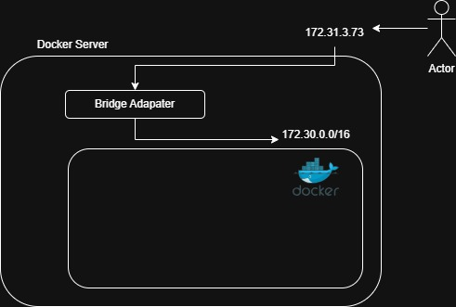

HOST
- container directly uses the host machine’s network.
- Container shares the same IP address and ports as the host system.
- Provides faster network performance but offers less security and isolation.
- Example:
docker run -d --name container1 --network host nginx

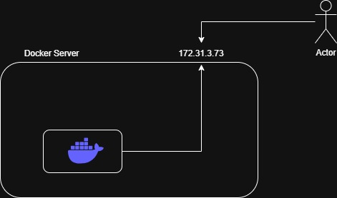

OVERLAY
- Overlay network is used to connect containers running on different Docker hosts.
- It creates a virtual private network between multiple Docker servers.
- Containers can communicate securely even if they are on different machines or VPCs.
- Mostly used in Docker Swarm and distributed applications.
- Overlay network works like a tunnel between Docker hosts.

CONCEPT:
Suppose:
- Frontend container runs on Server-1
- Backend container runs on Server-2
Using overlay network:
- Both containers communicate like they are in the same local network.

COMMANDS
- Initialize swarm
docker swarm init
- Create overlay network
docker network create -d overlay my_overlay
- Create service using overlay network
docker service create --name web --network my_overlay nginx

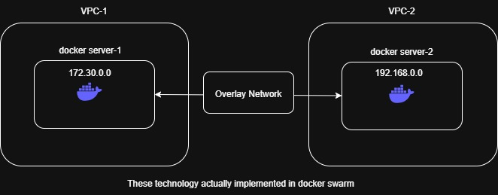

IPVLAN
- IPvlan allows containers to get separate IP addresses.
- Containers share the host machine’s MAC address.
- It provides better performance and simpler network management.
- Used in large-scale container environments.

MACVLAN
- Macvlan allows containers to appear as physical devices on the network.
- Each container gets its own MAC address and IP address.
- Containers communicate directly with the physical network.
- Used when containers need to behave like real servers.

NONE
- No networking is provided to the container.
- Container is fully isolated (no internet access and no communication with other containers).
- Used for high security or testing applications without network access.
- Commonly used for sensitive applications or databases that should not be exposed to the network.
- There is no public as well as private ip to the container.
- Example:
docker run -d --name nginx_container --network none nginx

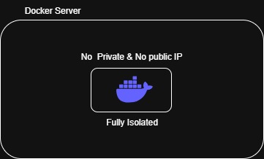

COMMANDS
- To check all the networks
docker network ls
- Delete Specific Network
docket network rm my_bridge
- Disconnect Container from Network
docker network disconnect my_bridge container1
- Delete Unused Networks
docker network prune

